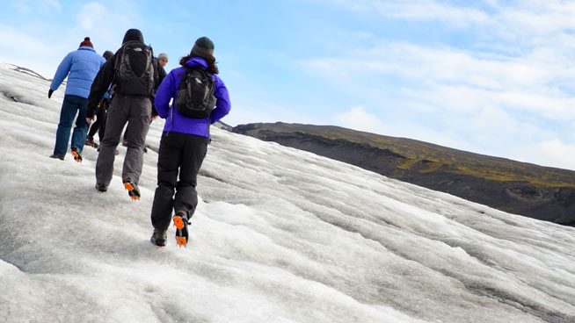

Application for Youth Participants for Explorer Belt in Italy, Icelandic Adventure and 25th World Scout Jamboree, South Korea - 2023

We’re delighted that you’re considering applying for an international adventure with Northumberland Scouts in 2023. Please ensure you have read the accompanying information about the three options available. Each one will suit different people and you may apply for more than one. Please complete the information and questions on this form. Alternatively, if you would prefer you can submit a video during which you answer the questions on this form.

If you have any questions about your application please email the trip leaders – contact details in the trip posters.

Stick your photo here!

Please stick a passport sized photograph in the box provided. This will help us recognise you during the selection weekend.

Section 1: PERSONAL INFORMATION
Full First Name: | Surname:
Address: | What are you known as?
 | Home telephone number:
 | Mobile telephone number (if you have one):
 | Email address (if you have one):
 | Date of Birth:
How old will you be on 1st August 2023?:
years months

What section are you currently in?  Scout Explorer  Network | Name of Scout Group/ Explorer Unit:
 | District:
What sections have you have been in since you started Scouting?
Beaver Cub Scout Explorer
Briefly tell us about what you do in your spare time:
Please provide any details of camps, expeditions and hikes you have been involved with, include duration of nights away and accommodation type.

Section 2: SELECTION DAY
**PLEASE NOTE: If you are applying for Explorer Belt only AND you will be over 18 at the start of the trip you do not need to attend a selection day**
Please confirm that you will attend a selection day (20th or 21st November 2021)
I WILL be able to attend |  | Yes No
Please select your preferred day to attend selection:
Saturday 20th November |  | Sunday 21st November
If you are UNABLE to attend one of the selection days please provide the reason.
Section 3: YOUR APPLICATION
In the space below, in no more than 200 words, tell us why you would like to take part in an International trip with Northumberland scouts.

World Scout Jamboree applicants ONLY - In 144 words (the size of a tweet in words) answer the following question:
The theme of the Jamboree is ‘Draw Your Dream’. What is your dream?

While we are out of the UK, we will need to show other Scouts from around the world what makes Northumberland special. Which areas/icons do you think we should include in this activity?
Section 4: Which trips are you applying for?
Please indicate which trips you would like to be considered for. Remember – you need to be age 16+ to take part in Explorer Belt. Please tick all that apply. If you have a preference please number your choices with Number 1 being your most preferred, otherwise please tick the ones you would like to apply for.

Explorer Belt ( )

Ice and Fire - Iceland ( )

World Scout Jamboree ( )

Would you like to be considered for more than one trip? Yes / No
(if the answer is Yes you MUST rank them above)

Parent/Guardian Details if currently under 18 (and Address if different from above)

Name(s) :

Address:

Email Address:

Signature: Date:

Section 5: SECTION LEADER’S COMMENTS
You need to ask your section leader to write a statement to support your application. They should comment on your experience in Scouting and the skills you can bring to the Unit.
Name:
Role in Scouting:
It is important that your District Commissioner knows that you would like to be part of the Jamboree Unit. Please ask your Group Scout Leader/Explorer Scout Leader to complete the section below to confirm that they have told your District Commissioner that you intend to apply.
Group Scout Leader / Explorer Scout Leader :

Signed: Date:

I confirm that the District Commissioner is aware that the above named person is applying to be part of the Jamboree Unit. Please tick here

Participant :
Signed: Date:

Please return this form to the address below or email WSJ@northumberlandscouts.org.uk

International Trips
Northumberland Scout Council
39 Horsley Avenue
Shiremoor
Newcastle upon Tyne
NE27 0UG

Forms should be received no later than 12 noon on Friday 5th November 2021.

